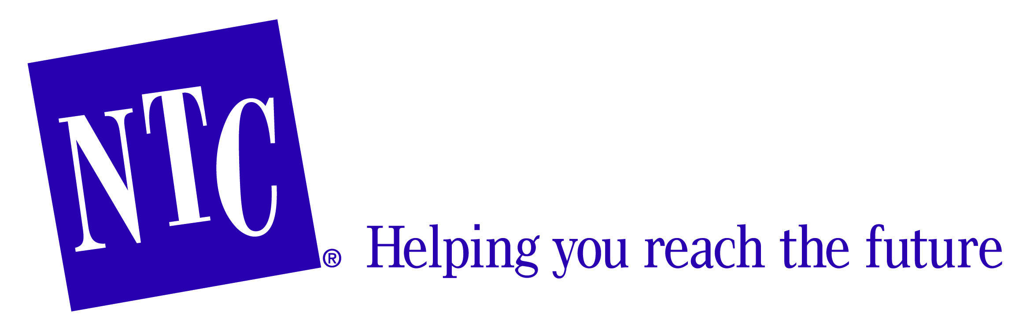
Please direct inquiries to:
Sheri O. Haugen-Hoffart, 701.328.4698
Investor Education Coordinator
shaugenhoffart@nd.gov

Eddie Eames, 800-858-3999 ext. 215
Manager, Client Services
eeames@ntccorporate.com

Western North Dakota Students Make Sense of Finance With Sketch Comedy

(Minneapolis, MN) Middle school students across North Dakota will learn skills crucial to financial literacy as they participate in sketch and improvisational comedy. North Dakota Securities Department proudly sponsors Mad About Money and joins together with The National Theatre for Children (NTC) to bring the show to schools at no cost. The tour begins October 6th and ends October 10th, stopping at schools in Sterling, Bismarck, Minot, Wilton and other cities.
During the forty-minute play performed by professional actors through a series of comedic sketches, students learn the difference between needs and wants, between saving and investing, between cash and credit and the importance of forming a savings habit. While the performance and educational content is completely scripted, the shows are built to incorporate certain moments of improvisation and lots of student participation. At the beginning of each scene, actors solicit information from the audience that is then humorously integrated into the show. “Lots of young people make financial mistakes that end up costing them huge amounts of money, time and worry,” says Karen Tyler, Commissioner of North Dakota Securities Department. “We want to equip these kids with the tools and the knowledge to make intelligent choices and to develop healthy saving and spending habits right from the start.”
Schools in Western and Eastern North Dakota have been able to participate in this program since 2005. “We have dedicated nearly a decade to preparing young people in our state to be a responsible addition to our economy,” Tyler continues. “It’s been a huge success, and we are very excited to partner with NTC and provide the program to schools again this year.”
The concepts examined in Mad About Money are reinforced by student workbooks and teacher guides for educators to use in their lessons. Schools also gain access to digital learning materials to supplement their lessons with interactive classroom exercises, quizzes and games based around the program. “The free show and resources are one part of what participating schools receive,” says Tyler. “The goal is always to encourage students to find out more, to pursue deeper understanding, and to explore these ideas in order to see how they apply to everyday life.”

About the North Dakota Securities Department
The mission of the Department is to protect North Dakotas investor through the administration of state securities laws and rules. The Securities Department is responsible for regulating the offer and sale of securities in North Dakota. It registers and monitors the firms and individuals selling securities or providing investment advice to North Dakotans, and registers securities offered and sold in the state. Through its investor education programs and resources, the department strives to help North Dakotans make informed investment decisions, avoid fraud and build financial security:www.nd.gov/securities

About NTC
In 1978, NTC dedicated itself to delivering entertaining and highly educational programs to positively motivate families, students and educators. We inspire young people – and their families – to explore important and timely curricular subjects including: wise energy use, science, technology, engineering and math (STEM), financial literacy, health and nutrition and environmental literacy, among others. Originally focused on delivering its programs via live theatre, NTC is now an award-winning educational content provider whose repertoire includes print and digital curriculum, professional development, extracurricular events and volunteers-in-the-schools. We have developed the art of teaching through educational story-telling into a science of its own, and are currently the largest in-school touring educational production company in the world. www.ntccorporate.com

